**Assignment JS 2 ( 04/01/2022 )**

**P1:- Give Result of asin(x) +acos(x)**

**var x, a, b, sum = 0;**

**x = 0.5;**

**a = Math.asin(x);**

**b = Math.acos(x);**

**sum = a + b**

**console.log(sum);**

**Output**

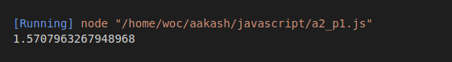

**P2:- Give Result of abs(x)*x**

**var x, a;**

**x = -25;**

**ans = Math.abs(x) * x;**

**console.log(ans);**

**Output**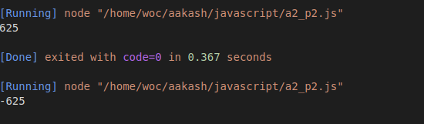

**P3:- Write program for given formula in attached image**



**var x, a = 5,**

**b = 12,**

**c = 1;**

**var b_2 = Math.pow(b, 2);**

**var _4ac = 4 * a * c;**

**var sq_sub = b_2 - _4ac;**

**var sq = Math.sqrt(sq_sub);**

**var _2a = 2 * a;**

**var add = (-b + sq) / _2a;**

**var sub = (-b - sq) / _2a;**

**console.log(b_2, _4ac, sq, sq_sub);**

**console.log("sum: " + add);**

**console.log("sub: " + sub);**

**Output**

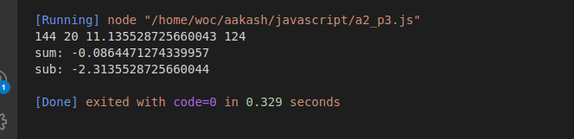

**P 3 with different method**

**var a = 1,**

**b = 0,**

**c = 0,**

**x1, x2, i, d, r;**

**d = (b * b) - 4 * a * c;**

**if (d > 0) {**

**x1 = (-b + Math.sqrt(d)) / (2 * a);**

**x2 = (-b - Math.sqrt(d)) / (2 * a);**

**console.log("sum: ", x1);**

**console.log("sub: ", x2);**

**console.log("d is positive");**

**} else if (d == 0) {**

**x1 = -b / (2 * a);**

**console.log("sum: ", x1);**

**console.log("d is 0");**

**} else {**

**r = -b / (2 * a);**

**i = Math.sqrt(-d) / (2 * a);**

**console.log("sum: ", i);**

**console.log("d is negative");**

**}**

